Delivery Project Report
1. Introduction
This project focuses on analysing delivery operations to understand cost patterns and find ways to optimise overall delivery expenses. Using Excel for basic cleaning, SQL for data analysis, and Power BI for visualisation, the goal is to identify which routes and regions perform efficiently and where cost improvements can be made.

2. Dataset Details
The dataset was first cleaned in Excel (removing blanks, fixing date formats, and checking for missing values) and then imported into SQL for analysis. It contains delivery records for the year 2024.
Columns Included
- delivery_date – Date of delivery
- region – Delivery region
- route_id – Route identifier
- deliveries – Number of deliveries
- distance_km – Distance travelled
- fuel_cost – Fuel expenses
- driver_cost – Driver expenses
- delivery_time_mins – Time taken
- redeliveries – Reattempted deliveries
- total_cost – Overall cost
- Additional calculated fields such as:
  - cost_per_km
  - cost_per_delivery
  - per_delivery_mins
These fields help measure route efficiency, cost distribution, and regional performance.

3. SQL Analysis Summary
After importing the cleaned dataset into SQL, multiple queries were used to understand delivery performance and cost behaviour.

1.Missing Data Check
Select *
From delivery_data
Where delivery_date is null
Or region is null
Or deliveries is null
Or total_cost is null;
Output: 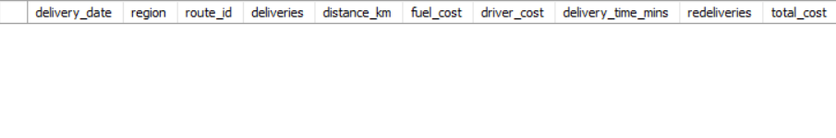
No major missing values were found after cleaning, since I checked everything in Excel before SQL data analysis

2.Route with Top 5 Cost per Delivery
Select
Route_id,
Round(sum(total_cost) / sum(deliveries), 2) as cost_per_delivery
From delivery_data
Group by route_id
Order by cost_per_delivery desc
Limit 5;
Output:
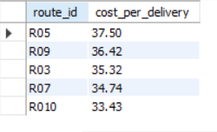
Used to compare which routes are expensive or efficient. (Used the round function to fix the decimals)

3.Route with Top 5 Cost per km
Select route_id,
Round(sum(total_cost)/sum(distance_km),2) as cost_per_km
From delivery_data
Group by route_id
Order by cost_per_km desc
Limit 5;
Output:
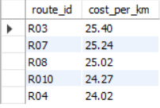
Identifies routes that incur higher costs relative to the distance covered.

4.Region-wise Cost
Select region,
Sum(total_cost) as total_region_cost
From delivery_data
Group by region
Order by total_region_cost desc;
Output:
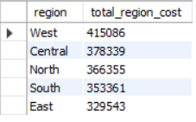
Shows which region contributes the most to total cost.

5.Monthly Cost Trend
Select
Date_format(delivery_date, '%y-%m') as month,
Avg(total_cost) as avg_cost
From delivery_data
Group by month
Order by month desc;
Output:
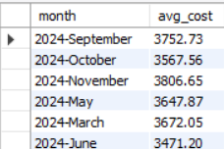
Useful for comparing delivery costs across different months.

6.Route Efficiency
Select route_id,
Avg(total_cost/distance_km) as avg_cost_per_km,
Avg(delivery_time_mins) as avg_time
From delivery_data
Group by route_id
Order by avg_cost_per_km;
Output:
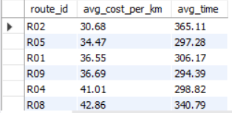
It helps identify which routes are efficient and which routes take more time or cost more.

7. Top 5 Most Expensive Routes
Select route_id,
Round(avg(total_cost),2) as avg_cost
From delivery_data
Group by route_id
Order by avg_cost desc
Limit 5;
Output:
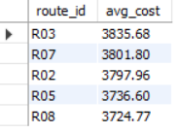
This query finds the five routes that have the highest average total cost. It helps highlight expensive routes that may need cost optimization or review.

8 . Delivery Density (Deliveries per KM)
Select route_id,
Round(deliveries/distance_km,2) as delivery_density
From delivery_data
Order by delivery_density desc
Limit 5;
Output:
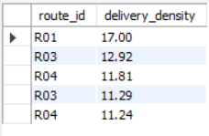
This shows how many deliveries happen per kilometre for each route. Higher delivery density means the route is more productive and efficient in terms of distance covered.

9 . Average Redelivery Percentage by Region
select region,
round(avg(redeliveries/deliveries)*100.00,2) as avg_redelivery_percentage
from delivery_data
group by region
order by avg_redelivery_percentage;
Output:
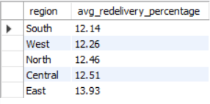
It helps identify which regions face frequent redeliveries, indicating possible delivery issues or customer availability problems.

Power BI Dashboard Summary Report

1. Overview
The Power BI dashboard was created to visually analyse delivery performance and cost optimisation across routes and regions.
It uses key KPIs, trend lines, regional comparisons, and cost breakdown charts to highlight insights that support decision-making.
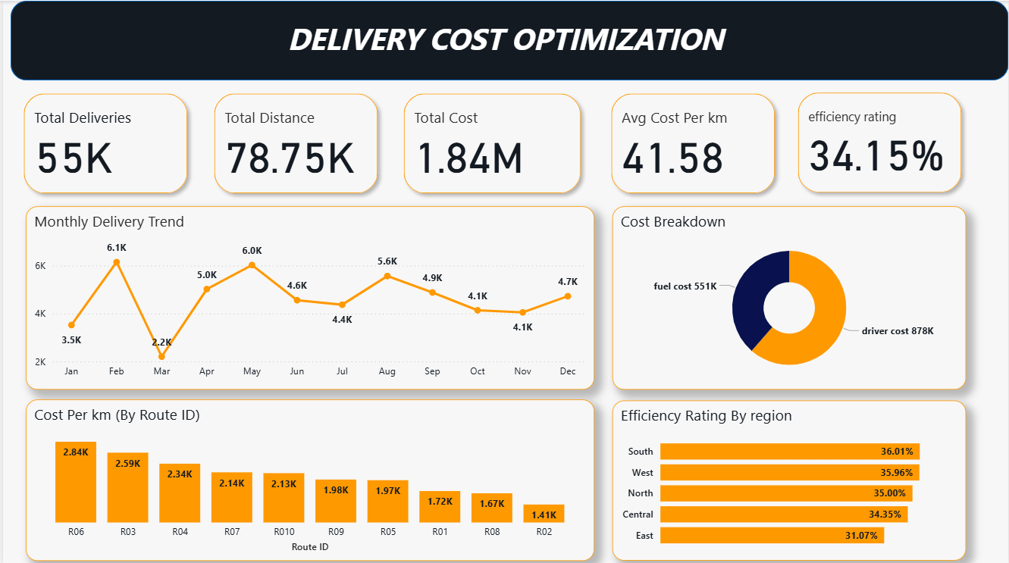
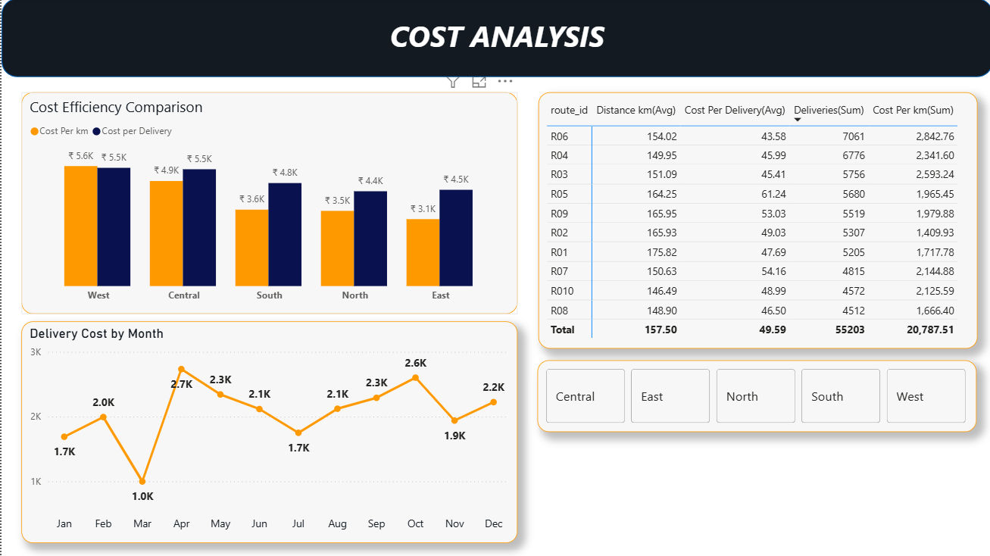
2. Key Performance Indicators (KPIs)
Displayed at the top of Page 1:
- Total Deliveries: 55K
- Total Distance Travelled: 78.75K km
- Total Cost: 1.84M
- Average Cost per KM: 41.58
- Overall Efficiency Rating: 34.15%
- Purpose:
These KPIs give a quick snapshot of overall operational performance and cost structure.

3. Monthly Delivery Trend
A line chart shows month-wise completed deliveries:
- Highest deliveries in February (6.1K) and May (6.0K)
- Lowest deliveries in March (2.2K)
- Moderate but stable performance from June to December
Insight:
Seasonal fluctuations exist, with strong performance early in the year.

4. Cost Breakdown
A donut chart splits total expenses into:
- Driver Cost: 878K
- Fuel Cost: 551K
Insight:
Driver cost is the largest cost factor, contributing the majority of total expenses.

5. Cost per KM (Top Routes)
A bar chart highlights the most expensive routes by cost per kilometre:
- R06 has the highest cost per km (2.84K)
- Followed by R03, R04, R07, etc.
Insight:
These routes may need route planning, route optimisation, or cost control measures.

6. Efficiency Rating by Region
A horizontal bar chart compares regional efficiency:
- South: 36.01%
- West: 35.96%
- North: 35.00%
- Central: 34.35%
- East: 31.07%
Insight:
The East region shows the lowest efficiency and may require improvement in distance planning, delivery scheduling, or operational processes.

7. Cost Analysis (Page 2)
A. Cost Efficiency Comparison (Region-wise)
This chart compares:
- Cost per KM vs
- Cost per Delivery
across regions (West, Central, South, North, East).
Insights:
- West and Central show slightly higher costs.
- South performs better with lower cost per km.
- East has low cost per km but high cost per delivery due to fewer deliveries.

B. Route-Level Table Summary
A detailed table shows:
- Average distance per route
- Average Cost per delivery
- Total deliveries
- Total cost per km
Highlights:
- R06 has the highest overall cost burden (2,842.76).
- R04 & R03 also show higher cost clusters.
- R02 is one of the more efficient routes.

C. Delivery Cost by Month
Another line chart shows monthly cost patterns:
- Peak cost: April, June, and October
- Lowest cost: March
Insight:
Cost does not always match delivery count, meaning operational efficiency varies month to month.

D. Region Selector (Slicer)
Interactive buttons to filter all visuals by:
- Central
- East
- North
- South
- West
This helps analyse each region individually.

8. Final Insights & Conclusion
From the Power BI dashboard:
Cost hotspots
R06, R03, and R04 are the most expensive routes.
Regions needing improvement
East region shows the lowest efficiency score and higher cost delivery patterns.
Cost structure concerns
Driver cost makes up the largest cost portion, signalling potential over-time or manpower optimisation need.
Delivery consistency
Deliveries fluctuate month to month, but overall performance remains strong in the first half and stable in the second half.
Overall Efficiency Rating
34.15% suggests there is room for significant improvement with route planning, fuel optimisation, and delivery scheduling.

